Matt Rees [mrees@rbge.org.uk](mailto:mrees@rbge.org.uk)

University of Edinburgh / Royal Botanic Garden Edinburgh

January 2024

How to download satellite imagery and load it onto your phone / tablet with QField for Android.

You can also load shapefiles and point coordinates

You can also load projects for surveying.

# Step 1 Project set-up

First open QGIS

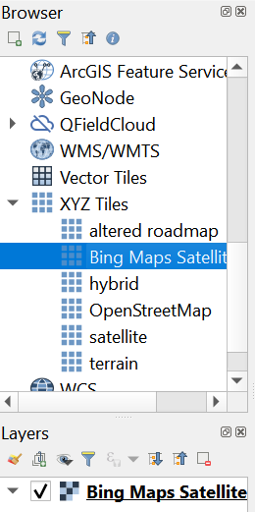Then load your preferred XYZ tile (if you don’t know how to do this. Go here <https://cawm.lib.uiowa.edu/xyz.html> ).

Make sure to set the CRS / projection you want to work in once in the field. Most phones / tablets will use WGS84 EPSG:4326 by default. You can do this in the bottom right corner.

Zoom into the area you are interested in (larger areas will take up more space and longer to download). Try the area you are in at the moment, that way, when you activate the location, you can check everything works well.

Go to the `Processing` tab and click on `Toolbox`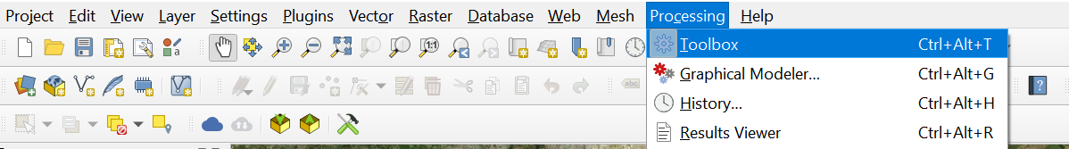

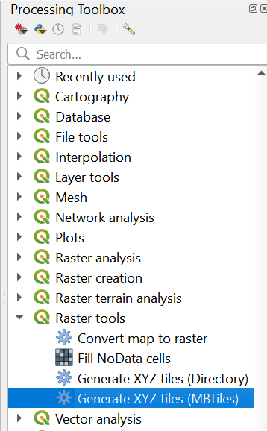Click on `Raster Tools` and select `Generate XYZ tiles (MBTiles)`

In the `Extent` field, select draw on canvas and then draw the zone you want sat imagery from.

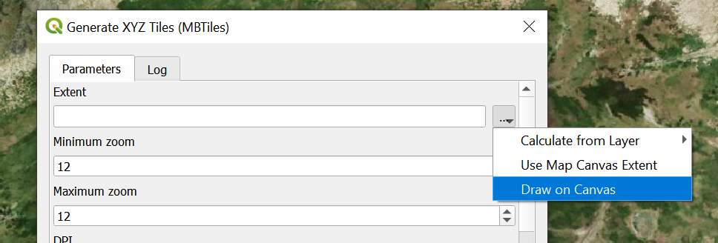

Minimum zoom can be kept at 12 or 10 and Maximum zoom should be 18 or 20. Note that the higher the zoom, the more processing time this will take.

DPI can be set to 300 for good high-quality maps.

Then you can select `Output file (for MBTiles) [optional]` and chose where you want to save the file.

Click on `Run`

You can now load that image tile and check it matches up with the satellite imagery by turning layers on and off.

You can now also load any shapefile, raster layer or plot coordinate you want. Here is an example of what I’m working on at the moment:

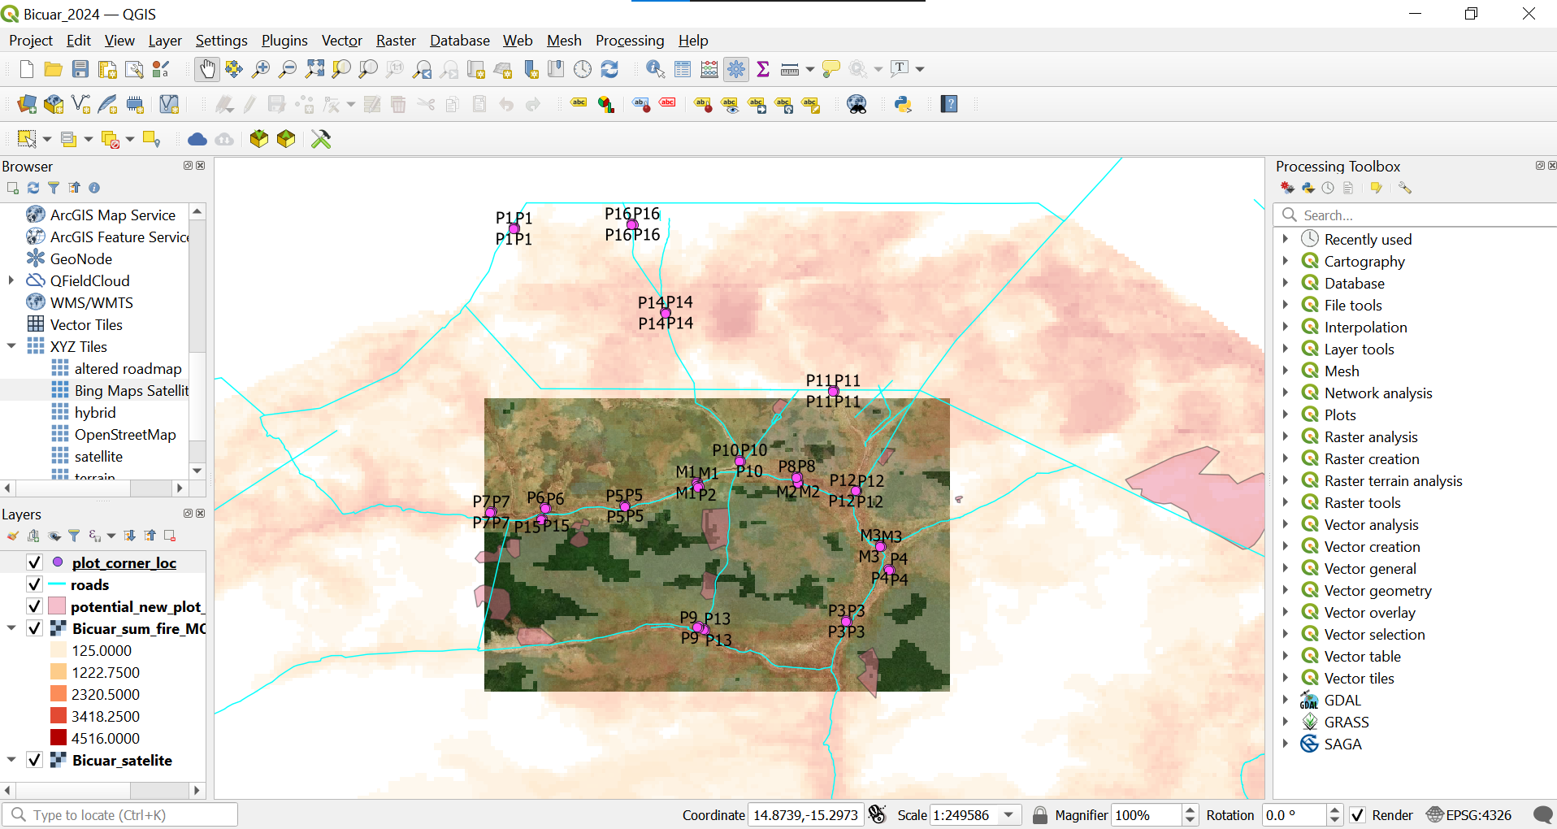

I have the sat imagery as the base layer. It doesn’t fill in the whole region, but it already weighs 1GB. Then on top I have added a raster of MODIS fire count. Then I have added shapefiles of potential new plot areas I want to investigate. Then I have a layer showing the roads. And finally, I have a layer showing the plot corners.

Once you have all the layers you need, simply go to the `Project` tab and hit `Save as` and save your project as a .qgz file.

# Step 2: Getting this to work on your phone / tablet

With your preferred device (phone / tablet) download the QField for QGIS app in the Android store.

Download all the files you have been working with (the project saved as .qgz file and all the layers you were using, including the sat imagery and every dependent file of the shapefiles, yes all those .cpg, .dbf, .shx etc.). Put these files in the “Internal Memory” somewhere if you can. This will speed up the app rather than saving the files somewhere onto an SD card.

Open the Qfield app and tap the + sign at the bottom right. Hit `Import project from folder` and select the folder that contains all your files.

You should now see all the files populate the window and select you project file.

You should see something like this:

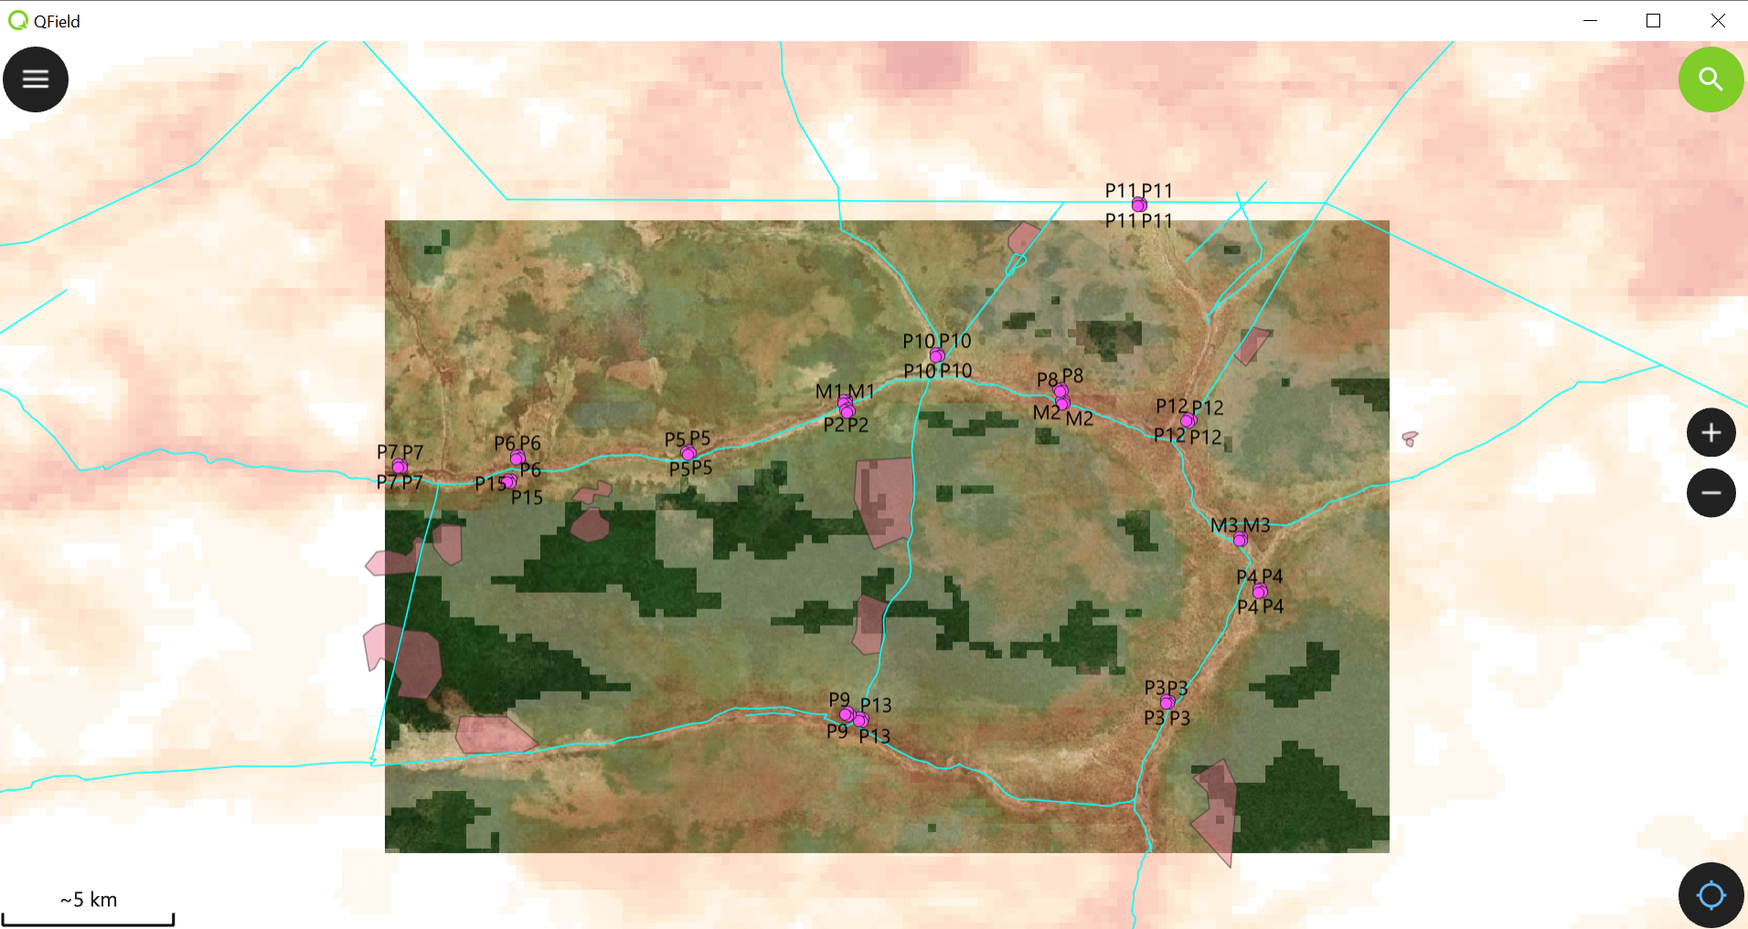

Once you’re in the field, turn your location on and voila! You can navigate using offline satellite imagery and any other piece of information you deemed useful to add to the map! You can even measure distances

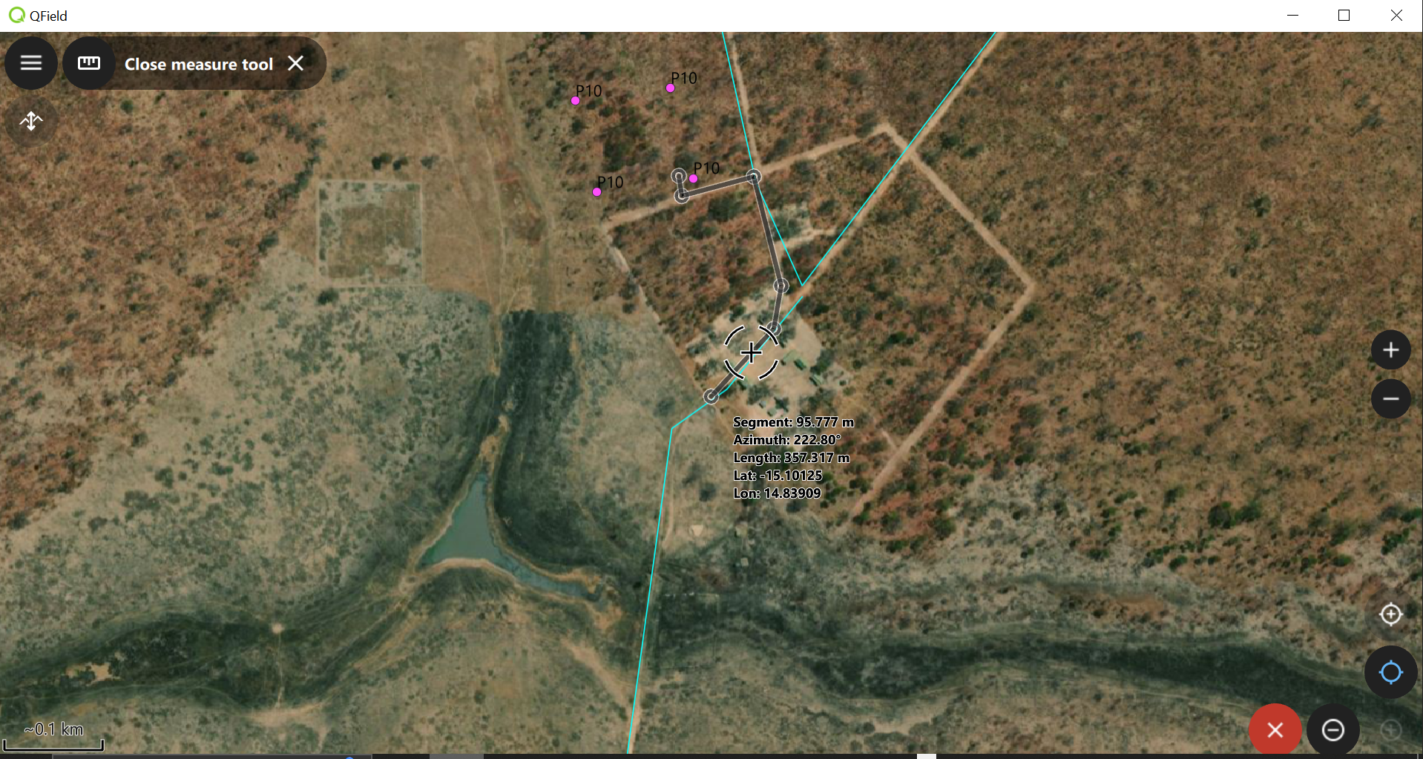

Our first plot is only 350m away from basecamp. Hallelujah!

# Step 3: Surveying

Ok so now we can think of how to set up a project if we want to survey an area. This might be for opportunistic collecting or systematic surveying of an area, like a plot.

I’ll work with a plot example for now.

Open QGIS and open a new project. I’m working with plot data as .csv files so I will load them here and select the x and y coordinates as spatial coordinates.

We want to transform this table to be a spatial object. I find it easier to work with Geopackages so I will transform my object into that format.

Right Click on the layer containing the csv table of plot stems and select `Export` then `Save Features As`

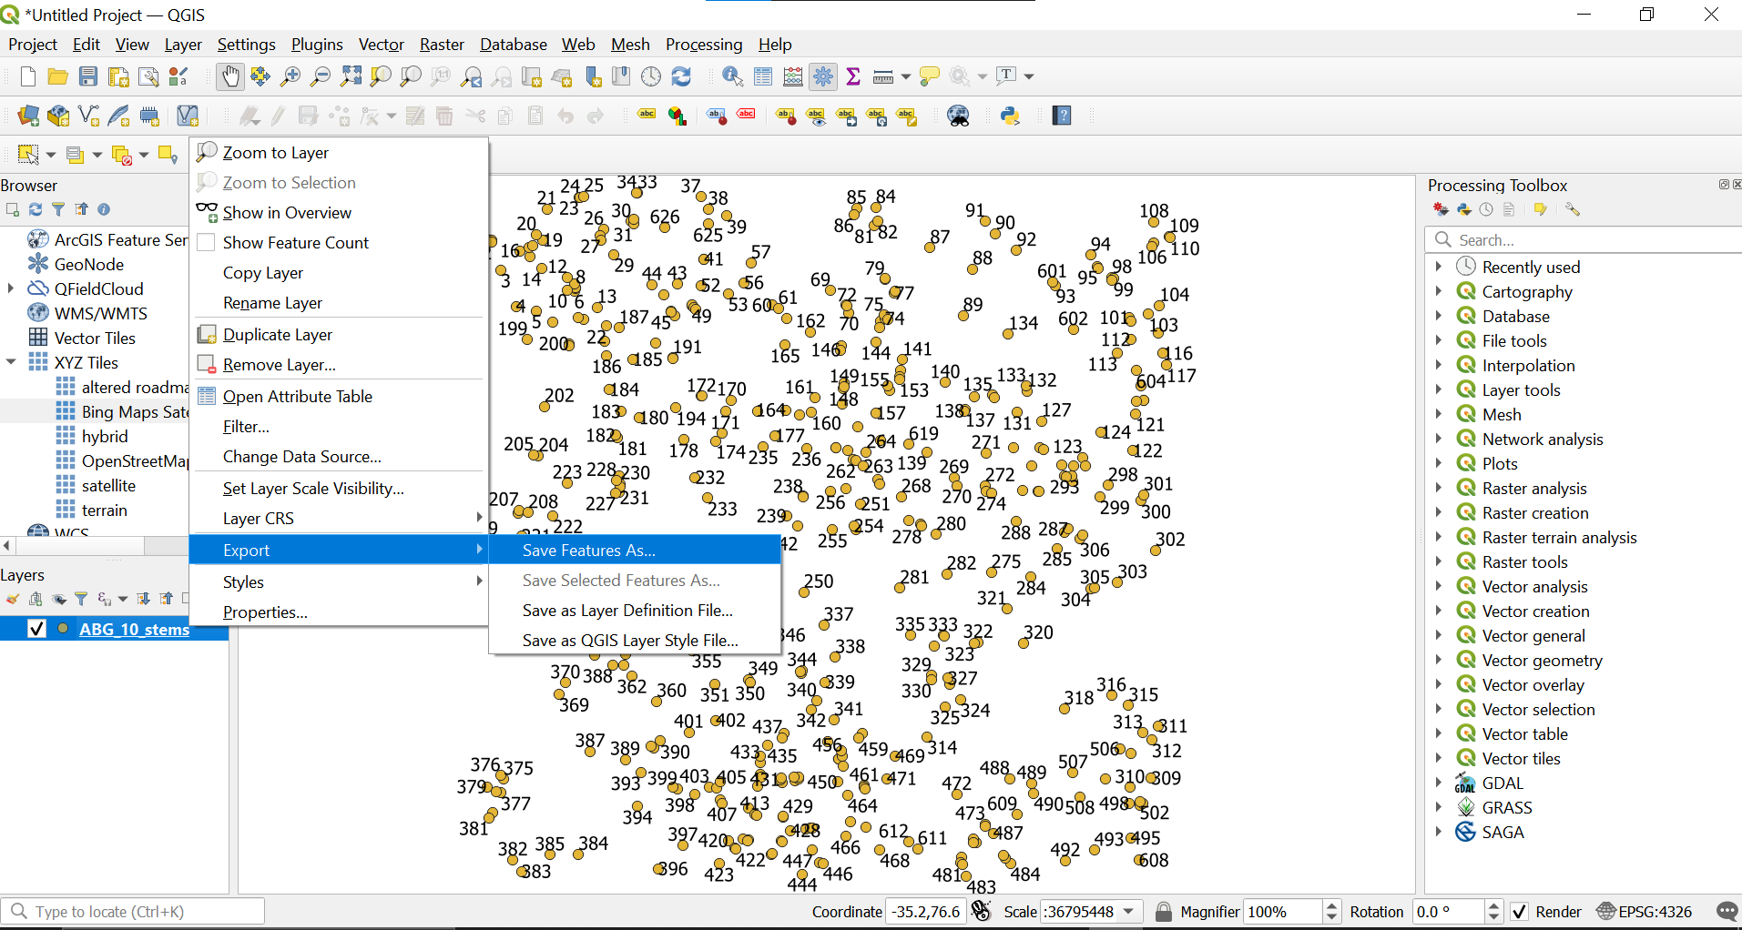

Select the `GeoPackage` format and chose what name the layer will have and where to save it.

Then right-click on the layer and select `Properties`.

Select the `Fields` tab and press the little pencil icon to toggle on editing mode.

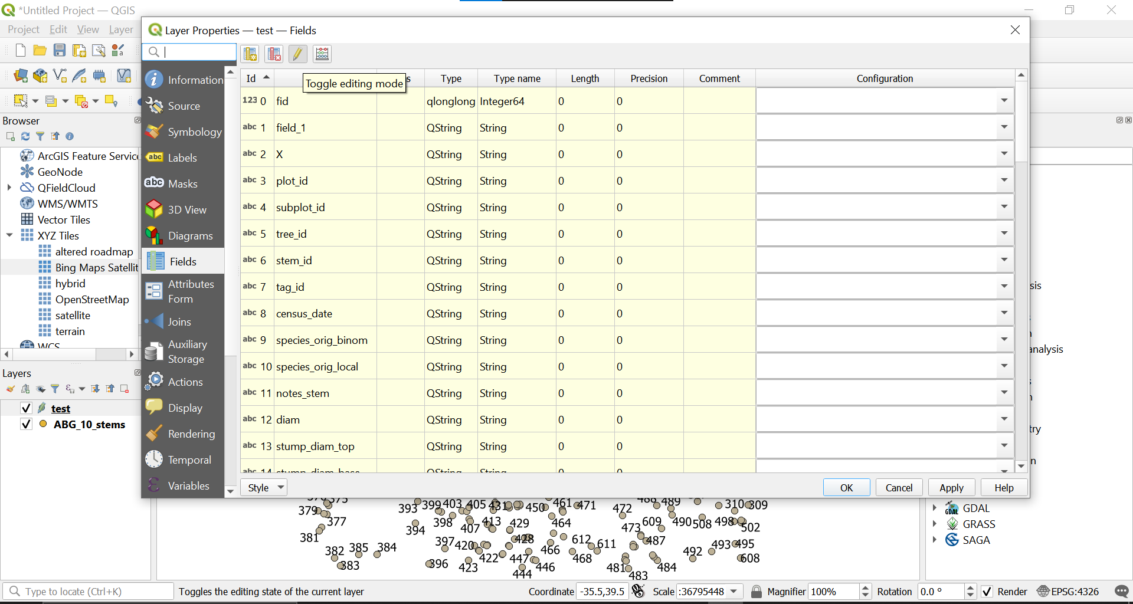

You can then add a new field called “Surveyed” and the type will be `text string`. Once this is done, hit `Apply`.

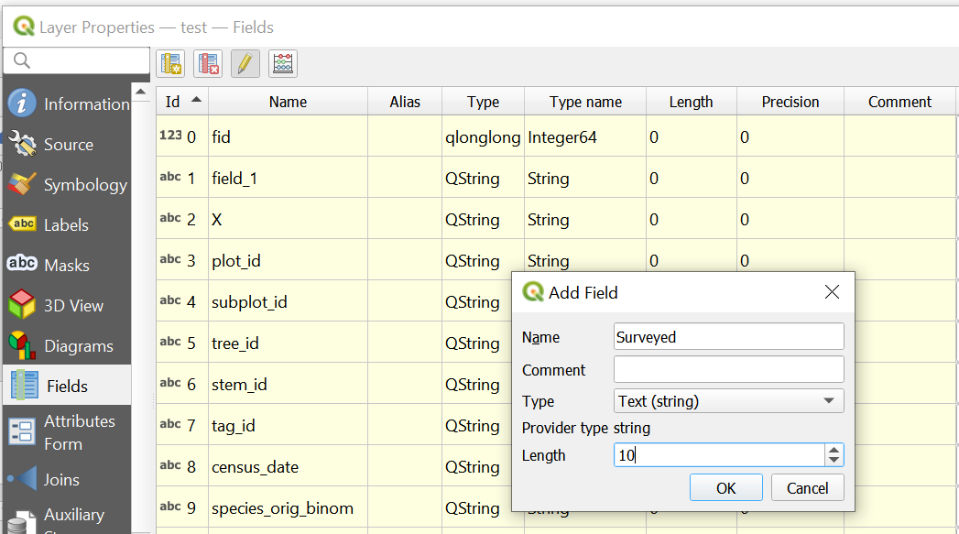

Now in the `Symbology` tab, select `Rule-based`. You should see there is already one field called ELSE. We can now add a new field which we will call `Surveyed`.  
Next to the `Filtered` tick box, enter “Surveyed” = ‘TRUE’ like so. You can select the colour you wish to use.

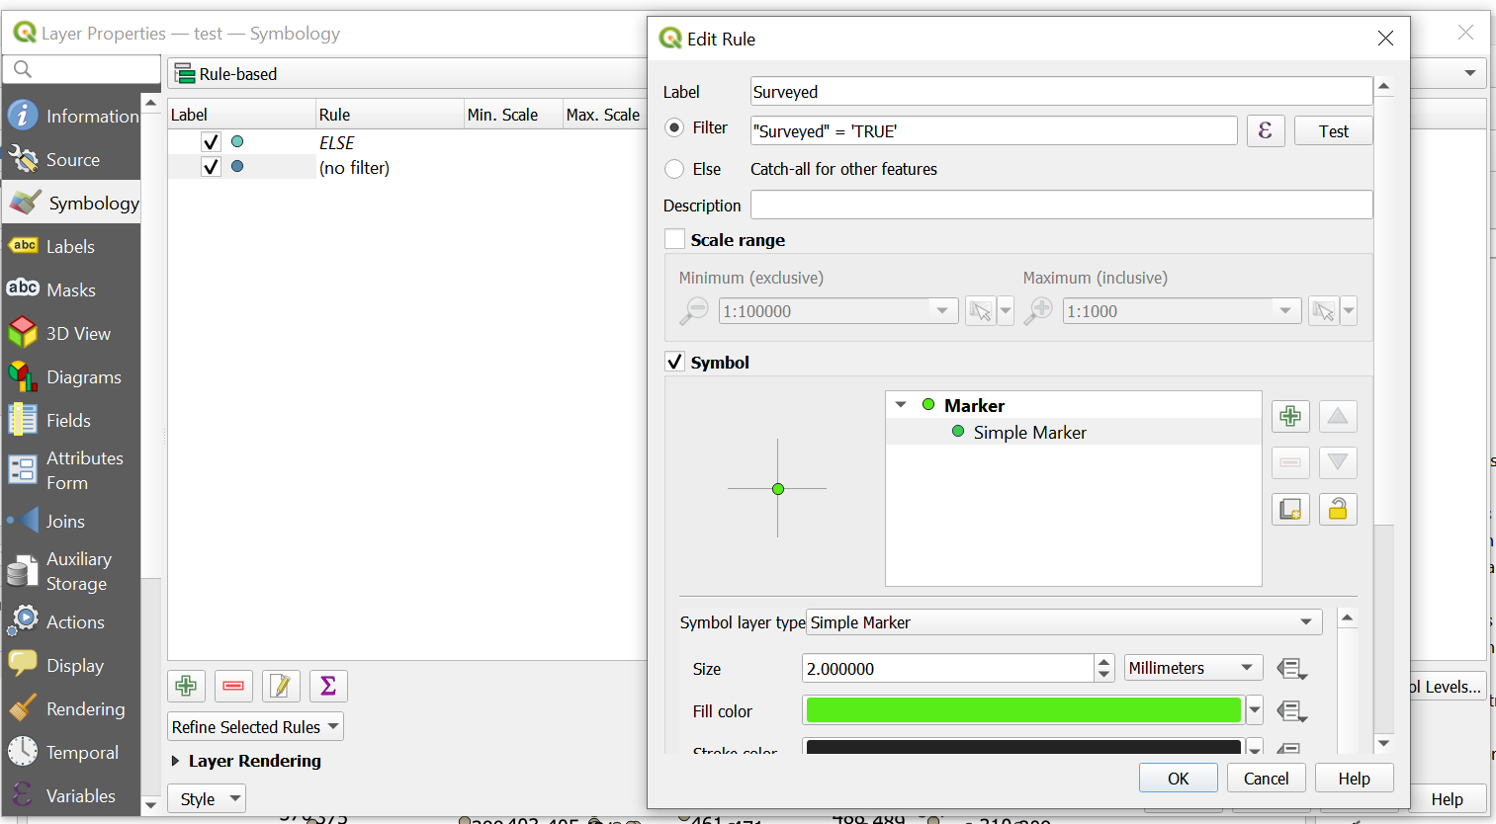

Hit OK and then Apply, and then OK again. The Properties box closes and we are then back onto our canvas.

You can then select a point using the `Identify Features` function. Check the last tab and you should see this new field which has appeared.

Now go back to the Properties and click on Attributes form. I have chosen the `drag and drop designer` and selected only the variables I’m interested in. The last one is our “surveyed tab”. In the right-hand side editor box, select `Widget Type` and chose “Checkbox”, then type the values TRUE and FALSE for checked and unchecked states and tick the boxes for “Not NULL” and “enforce not null constraint”. Hit Apply and OK.

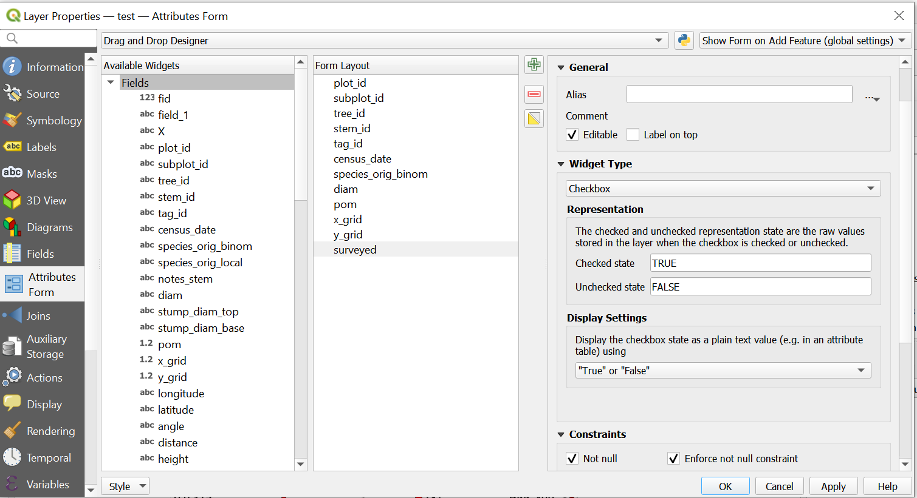

Now follow these steps:

1. Click on toggle editing
2. Select the `Identify Features` button
3. Chose a point and click on it
4. Click on `view feature form` which will bring up the features attributes table
5. Check the “surveyed” tick box
6. Press OK

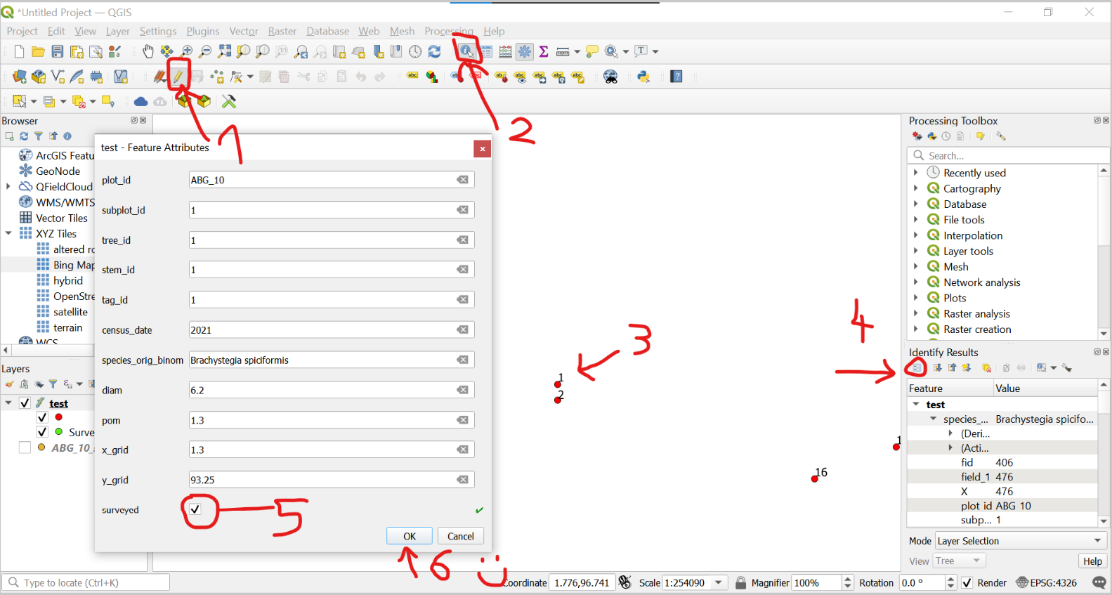

You can see that the point you selected has now turned the colour of the ‘TRUE’ surveyed.

There are a few more steps you can take to customise your project but I’m writing this tutorial in a hurry so I will skip to the next part.

We now want to download the `Qfiled` plugin. Hit the `Plugins` tab, then install plugins and search for QField Sync.

Once this is done, hit the `Package for QField` button that has just appeared on the dashboard.

Chose where to export the file and voila. Repeat the same procedure as in step 2 and you should be good to go!

You can now select which stems needs surveying and update the diameter or the species ident or any other field you needed to modify. You can even select the layer and toggle edit to add new points to the plot.

The end